Describe the module system in JavaScript, including CommonJS and ES Modules. Discuss their significance for code organization.
JavaScript's module system provides a structured way to organize and reuse code by splitting functionality into manageable, reusable pieces called modules. Modules help developers maintain clean, readable, and maintainable codebases by encapsulating functionality and dependencies.
Key JavaScript Module Systems
1. CommonJS
- Definition: CommonJS (CJS) is the module system used in Node.js, designed for server-side JavaScript. It was one of the first widely adopted JavaScript module standards.
- Key Features:
  - Synchronous: Modules are loaded synchronously at runtime.
  - Export Syntax: Uses module.exports to expose functionality.
  - Import Syntax: Uses require() to load modules.
- Example:
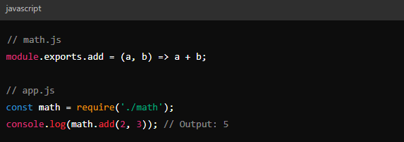

Limitations:
Not suitable for the browser directly, as browsers typically load files asynchronously.
Tight coupling to Node.js runtime, making it less flexible for front-end environments.
2. ES Modules
Definition: ES Modules (ESM) are the standard JavaScript module system introduced in ECMAScript 2015 (ES6). They are now supported natively in modern browsers and Node.js.
Key Features:
Asynchronous: Modules can be loaded asynchronously, making them suitable for web browsers.
Export Syntax: Uses export or export default to expose functionality.
Import Syntax: Uses import to load modules.
Example:
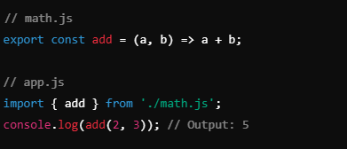

- Advantages:
  - Native support in browsers and Node.js.
  - Static structure: Tools like bundlers and linters can analyze dependencies at build time, optimizing performance.
  - Tree-shaking: Unused exports can be removed automatically during the build process.

Significance for Code Organization
1. Improved Maintainability:
- Modules allow developers to split large codebases into smaller, focused files, making it easier to maintain and debug.
2. Code Reusability:
- By exporting and importing specific functionalities, modules promote reuse across different parts of the application.
3. Encapsulation:
- Each module can have its scope, reducing the risk of variable name collisions and side effects.
4. Dependency Management:
- Modules explicitly declare dependencies, improving clarity and enabling automated tools to manage and resolve them.
5. Better Collaboration:
- In a team environment, splitting functionality into modules enables parallel development without conflicts.

Transition and Coexistence
While CommonJS is still widely used in legacy projects and Node.js-based systems, ES Modules are becoming the de facto standard, especially for web applications. Tools like Babel and bundlers (e.g., Webpack, Rollup) allow projects to interoperate between these systems, ensuring smooth transitions and compatibility.
In summary, both CommonJS and ES Modules play a crucial role in modern JavaScript development, facilitating organized, reusable, and maintainable code. While CommonJS laid the foundation for modularity in JavaScript, ES Modules have pushed it into a standardized and future-proof approach.

